Table of Contents

1. Proposed Design 2

1.1. Business Architecture 4

1.2. Data Architecture 4

1.2.1. Database Relationships 4

1.2.2. Data Flow 4

1.2.3. Data types, Classes and Schemas 5

1.2.4. Physical Architecture 6

1.2.5. Disaster Recovery & Business Continuity 6

1.3. Applications Architecture 7

1.3.1. Proposed Applications Architecture 7

1.4. Infrastructure Architecture 12

1.4.1. Development Environment 12

1.4.2. Testing Environment 12

1.4.3. User Acceptance Test (UAT) Environment 12

1.4.4. Training Environment 12

1.4.5. Production Environment 12

1.4.6. Platforms 12

1.5. Security Architecture 13

1.5.1. Proposed Security Architecture 13

2. Acceptance Criteria <Requires Further Elaboration and Review> 17

2.1. Quality Attributes 18

2.2. Functional Acceptance Criteria 18

2.3. Technical Acceptance Criteria 18

2.4. Implementation Acceptance Criteria 18

3. Implementation Considerations 19

3.1. Deployment 19

3.2. Infrastructure Management 19

3.3. Maintenance Plan 20

4. Final Design 20

Appendix A - Terminology and Acronyms 21

**Table of Figures**

Figure 1: 3-Server Pattern 3

Figure 2: ERD 4

Figure 3: Physical Architecture 6

Figure 4 - Module Application Architecture 8

Figure 5: Integration Architecture - Application Model 11

Figure 6: Azure DevOps Conceptual Diagram 19

Figure 7: Azure Monitoring Tools 20

**Table of Tables**

Table 1: Application Users and Role 15

Table 2: Users classification 16

Table 3: Abbreviations 21

1. Proposed Design

Weather App adopts the High Availabality internal and external application – Three Server pattern. It implements the Germany weather business needs, enables the users to access the solution through web browsers, mobile apps, and processes.

The three logical and physical components of Germany weather solution are the:

* Presentation layer hosted on the Web server to handle and serve the users requests.
* Application layer hosted on the application server to implement and run the business logic.
* Data layer hosted on the Database server to house the solution data and make available for the business layer to consume.

Microsoft IIS will be used for the web server(s), and for the database management systems cluster an Active/Passive configuration will be used where the Passive node will not be up and running until the Primary fails (Cloud configuration and automation allows us to automatically bring the passive on and up when the primary goes down) – Failover clusters.

The below diagram illiustrates the solution pattern taken from the standard Bricks and Pattern recommendations.



Figure 1: 3-Server Pattern

The proposed number of servers may be different during and after the implementation of the solution as performance and scalability information become more tangible and available. Auto-scaling technique will be provided to support the peak time requests as needed.

* 1. Business Architecture
     + 1. Business Processes

TBD

* + - 1. Key Business Capabilities
* Audit trails
* Big data analytics
* Pricing
* Weather temperature aggregation
  1. Data Architecture
     1. Database Relationships

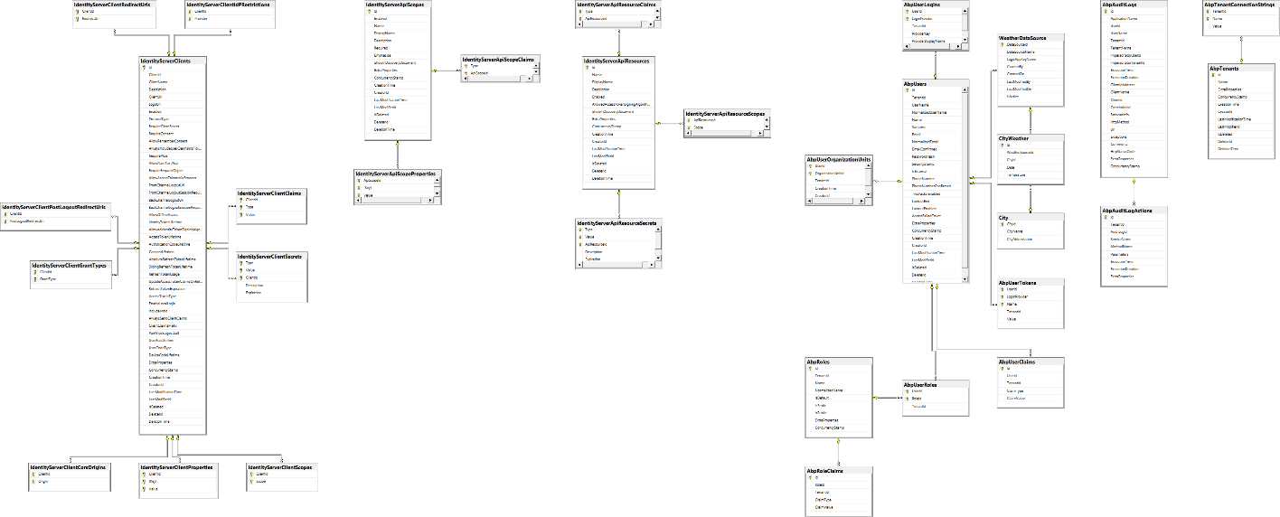

Figure 2: ERD

* + 1. Data Flow

TBD.

* + 1. Data types, Classes and Schemas

Data types

Weather solution will process and store the weather information, including the client information, … etc.

The common data types that will be stored in the database are:

* Varchar
* Int
* Decimal
* Datetime
* Datetime2
* Special data types: hash values, images, special characters from other languages, etc. (The need for such data types could arise from different modules).

Data schemas

The purpose of creating different schemas is to store the database objects into different file groups to improve performance, ensure module data integrity, deliver separation of concerns among modules, and ease of search and maintenance.

According to the current modules defined, the proposal is to design a database schema per module that represents the business domain for that module, if exceptions arise where multiple modules need to access a common schema; elaboration and justification of these use cases and scenarios will need to be presented in the approved form of solution design communication / documents (SDD, GSD). System usage tables will be in an independent schema.

* + 1. Physical Architecture



Figure 3: Physical Architecture

* + 1. Disaster Recovery & Business Continuity

For backup and disaster recovery plan, wheather application will follow the guidelines and the solutions listed under the Azure cloud which leverages Microsoft Azure CD and continuous delivery services. Also the databases will be backedup twice a day as well as replication techniques.

* 1. Applications Architecture
     1. Proposed Applications Architecture

Weather modules leverage ASP.NET Core Web API framework. One of the major benefits of the this technology architectural pattern is to achieve separation of concerns helping to scale the application complexity since it is easier to code/debug/test an area with a single job. Also, for the front-end module(s) Weather app will leverage the power of ReactJS library to build responsive and well structured web app.

The below diagrams represents the application architecture of the custom developed and built modules in weather application. Each of the layers is elaborated on below.



Figure 4 - Module Application Architecture

* + - 1. Application Structure/Layers/Components
         1. Tiers/Functions per tier

As mentioned above, Germany weather Application will be delivered leveraging three tiers each handling a separate concern from a design and architecture perspective. The below section lists the tiers:

* **Presentation Tier:** Responsible for handling the user interface consumed by the end user, receiving and sending the https requests and responses from and to the end user, interacting with the middle tier to pull and consume data related to the front-end requests and needs.
* **Business Tier:** Responsible for orchestrating requests sent from the presentation tier and/or from the integration tier, running the business validation rules within the module / application, interacting with common libraries provided to the whole solution to consume and leverage shared services, interacting with the database to retrieve / update / store data post application orchestration and business rules validation.
* **Data tier:** Represents the relationship database management system that stores the application data, interacts with the business tier through the data access layer, and to tailor towards any transactional reports.

Weather Application will make use of common services that is provided to all modules of the applications. Here is a list of the some shared services:

* **Data Warehouse**: Will integrate with the core modules to serve reporting needs. To be discussed in more details in the future.
* **Interface Service Layer:** Will integrate with the core modules, databases, data warehouse to handle internal, external, inbound and outbound interface files, APIs, … etc..
* **Self Service Portal:** Will provide canned and ad hoc reporting presentation and access, acting as the repository of outbound interfaces, provide access to application status and notifications.
* **Integration Layer:** Will integrate weather application’s modules together by levering Microsoft Azure Integration Services, the four products provided through this layer are: Azure Service Bus, Azure API Management (provides API gateway functionality including the ability to monitor the published APIs, view activity logs and metrics), Redis Cache service which will be responsible for the distributed cache service and Azure Logic Apps which handles workflows of fetching the weather from different sources.
  + - 1. Development Framework/Tools
* Microsoft .Net 5 framework
* ASP.Net Core
* Microsoft SQL Server
* Redis cache
* ReactJS
* SonarQube for static code analysis
  + - 1. Runtime Framework

TBD.

* + - 1. APIs

Weather Application will make available multiple services through every module to be consumed when needed by other modules, APIs will expose these services internally to the application’s modules. They will be published using Azure API Management product. This integration will go through Azure API Management – API gateway to ensure proper authentication and to leverage the various functionalities provided such as APIs monitoring and reporting.

* + - 1. Middleware

The “Emerging” Azure Integration Services will be the selected product for integration purposes pending the approval. The five products provided through these integration services are:

* [Service Bus](https://docs.microsoft.com/en-us/azure/service-bus-messaging/service-bus-messaging-overview): A loosely coupled way for applications and integration technologies to communicate via messaging. This service provides queues that hold messages until they can be picked up by the receiver. This lets applications and integration software communicate asynchronously, even across diverse technology platforms. This supports communication via events. Rather than polling a queue in a messaging service.
* [API Management](https://docs.microsoft.com/en-us/azure/api-management/): A way to publish and manage application programming interfaces (APIs). The API service makes software services accessible to other software, whether those services run in the cloud or on-premises.
* [Logic App](https://docs.microsoft.com/en-us/azure/logic-apps/): A straightforward way to create and run integration logic leveraging a graphical tool for defining workflow logic.
* [Redis Cache](https://docs.microsoft.com/en-us/azure/azure-cache-for-redis/cache-overview): High-performance caching service that provides in-memory data store for faster retrieval of data. It is based on the open-source implementation Redis cache. This ensures low latency and high throughput by reducing the need to perform slow I/O operations. It also provides high availability, scalability, and security.
* [Azure Key Vault](https://docs.microsoft.com/en-us/azure/key-vault/secrets/quick-create-portal): cloud service that provides a secure store for secrets. You can securely store keys, passwords, certificates, and other secrets. Azure key vaults may be created and managed through the Azure portal. In this quickstart, you create a key vault, then use it to store a secret.

The below digram illustrates the flow and form of communication between various modules, within the module, and through the Azure Integration Services.



Figure 5: Integration Architecture - Application Model

* + - 1. User Interfaces

Thin Client will be the User Interface pattern adopted by both applications. Web browsers will be rendering and representing HTML, Javascripts, CSS as the form of representation and interaction with the users.

* 1. Infrastructure Architecture

Infrastructure architecture is currently being worked on and will be reflected on the soonest.

* + 1. Development Environment

TBD.

* + 1. Testing Environment

TBD.

* + 1. User Acceptance Test (UAT) Environment

TBD.

* + 1. Training Environment

TBD.

* + 1. Production Environment

TBD.

* + 1. Platforms

For all environments listed above they rely three types of platforms:

1. **IaaS:** a service that provides access to storage, networking and computing resources from a third-party. This is what all of our virtual machines and app services will be leveraging.
2. **PaaS:** a service that provides access to a cloud-based platform used to build, test and deliver applications. This is what Azure Integration Services will be leveraging.
3. **SaaS:** a service that provides applications hosted by a third-party which is typically accessed via the internet . This is what **Azure DevOps** will be leveraging.
   1. Security Architecture
      1. Proposed Security Architecture

The use of ASP.Net Core enables the solution to configure and manage security for the application. ASP.Net contains features for managing authentication, authorization, data protection, HTTPS enforcement, application secrets, anti-request forgery protection and CORS (Cross-Origin Resource Sharing) management. This Authentication middleware will be integrated with the Identity Server to implement the SSO and use the proper security flow.

* + - 1. Security Components

##### Authentication Service

The Shared Services Component will provide a common authentication service to be used by any Module. The authentication service will authenticate the user using the authorative authentication service (Identity Server as of the time of this document was written). The authentication service will also retrieve some common user attributes (email id, first name, last name, etc) that will be used by the application. This information will be wrapped in a JSON Web Token (JWT) and passed back to the caller upon successful authentication.

JSON Web Token is an open standard ([RFC 7519](https://tools.ietf.org/html/rfc7519)) that defines a compact and self-contained way for securely transmitting information between parties as a JSON object. This information can be verified and trusted because it is digitally signed. JWT will be passed in the Authorization header using the Bearer schema.

Using the API controllers will be configured to check for authentication via the use of the [Authorize] attribute. The [Authorize] attribute limits access to the Controller or action to authenticated users. Use of the [AllowAnonymous] attribute will be prohibited except for the login page. Verification of this programming standard will be handled via code reviews and (potentially) automated static code scanning using rule sets.

##### Authorization Service

The Shared Services Component will provide a common authorization service to be used by any Module. The authorization service will be based on the ASP.Net Core authorization framework. The ASP.Net Core authorization framework provides a simple, declarative role and a rich policy-based model. Authorization is expressed in terms of requirements and handlers evaluate a user’s claims against the requirements. Imperative checks can be based on policies which evaluate both the user identity and properties of the resource that the user is attempting to access (e.g., the record in the database).

##### HTTP Strict Transport Security

The Shared Services Component will provide a common routine that can be used by any Module to configure the Web applications at startup to:

* Redirect HTTP requests to HTTPS
* Send the HTTP Strict Transport Security Protocol (HSTS) headers to clients.

Verification of this programming standard will be handled via code reviews.

##### Authenticated REST APIs

All REST APIs exposed by one Module for use by that Module or other Modules will require a JSON Web Token (JWT) to be passed as part of the API call.

In addition, the API Management Gateway (part of Azure Integration Services) will require that all calls be authenticated.

##### Preventing SQL Injection

Applications frequently take external input (from a user or another external agent) and perform actions based on that input. Any input that is directly or indirectly derived from the user might have content that uses the syntax of the target language in order to perform unauthorized actions. When the target language is SQL, this manipulation is known as a SQL injection attack. A malicious user can inject commands directly into a query and drop a database table, cause a denial of service or otherwise change the nature of the operation being performed.

The Data Access Layer will use Entity Framework (EF) Core (which is the version of EF compatible with ASP.Net Core). EF Core serves as an object-relational mapper (ORM), enabling the developers to work with the database using .NET objects, and eliminating the need for most of the manually written code they usually write. EF prevents SQL injection by using parameterized queries and stored procedures instead of injecting literals directly in the SQL command.

##### Secrets Management

To protect secrets (sensitive data) in the developer’s local environment, the development team will use the Secret Manager tool that is incorporated in Visual Studio. The Secret Manager tool abstracts away the implementation details, such as where and how the values are stored. The Secrets Manager tool doesn’t encrypt the store secrets and can’t be treated as a trusted store. It is for development purposes only. Secrets are stored as name-value pairs.

The ASP.Net Core Configuration API provides access to Secret Manager secrets. The user secrets configuration source is automatically added in development mode. User secrets can be retrieved via the Configuration APIs.

To protect secrets in higher level environments (UAT, PROD), the system will use the Azure Key Vault. Azure Key Vault is a cloud-based service that assists in safeguarding cryptographic keys and secrets used by applications and services. Azure Key Vault provides support for the following scenarios:

* Controlling access to sensitive configuration data

While the name of the secret remains the same across environments, the value of the secret is different. The ASP.Net Core Configuration API provides access to secrets stored in the Azure Key Vault in the same manner as in the development environment. The Shared Services Component will provide a common routine to establish access to the Azure Key Vault in a secure manner.

In order to authenticate to the Azure Key Vault, a Managed Service Identity (MSI) will need to be established (see [here](https://docs.microsoft.com/en-us/azure/key-vault/tutorial-net-create-vault-azure-web-app) for an overview).

* + - 1. User Access

There are several groups of users:

* Authenticated end users
* Service Accounts (aka, Software users)

**Authenticated End Users:** Within the Shared Services Component, the authentication service will authenticate the user using the authentication service. The authentication service will also retrieve some common user attributes (email id, first name, last name, etc) that will be used by the application. This information will be wrapped in a JSON Web Token (JWT) and passed back to the caller upon successful authentication.

**Service Accounts (i.e., Software Users):** Service accounts will be used with Azure Integration Services (API Management Gateway, Service Bus and Logic Apps) and will comply with the agreed naming convention, password complexity and periodic password reset.

Table 1: Application Users and Role

| **Group** | **Role Description** | **Permissions** |
| --- | --- | --- |
| Admin | Users with this role can control the data sources and all lookups used by the system. Also they control the authentication and authorization of the users |  |
| Retail Investor | Individual or non-professional investor who buys and sells Natural gas contracts through brokerage firms |  |
| Institutional Investor | Person or organization that trades Natural gas in large enough quantities that it qualifies for preferential treatment and lower fees |  |

Service accounts will be documented and provided as they are requested throughout the iterative development process.

* + - 1. Data Security

Germany Weather App includes personal identifiable data in the form of Social Security number, addresses, email accounts, customer’s names and phone numbers and therefore classified as confidential data.

Table 2: Users classification

| **Classification** | **Security Control** | **Risk Factor** | **Restrictions/**  **Considerations** | **Relationship to California Public Records Act** | **Examples** |
| --- | --- | --- | --- | --- | --- |
| **Confidential** | Highest | Unauthorized disclosure, alteration or destruction could cause a significant level of damage to the client (liability, financial loss or serious damage to credibility) | Information in this category includes that which is protected by the laws pertaining to privacy, confidentiality, public safety. Also information protected by confidentiality agreements (contracts). | Information that is (1) not a “public record”, (2) subject to mandatory non-disclosure laws or (3) a Country policy of nondisclosure or agreement with a third party that requires assertion of a discretionary exemption to disclosure. | TBD |
| **Sensitive** | Moderate | For Official Use Only. Unauthorized disclosure, alteration or destruction could cause a moderate level of risk to the client conducting business, functioning or credibility. | Information in this category includes that which is intended for internal use only and not for general circulation outside the Country; information that may fall within discretionary exemptions. | Information that is “public record” by definition but subject to discretionary exemptions that are asserted at the option of the Country. | TBD |
| **Open to Public** | Low | No risk to client | Information has reviewed and redacted for legal compliance. | None – reviewed and redacted of all confidential & discretionary info | TBD |

For the weather web application will require HTTPS communication between users’ web browsers and the applications’ web servers. All REST API calls will be performed via HTTPS.

All databases are encrypted with Transparent Data Encryption (TDE).

* + - 1. Auditing

When required, auditing (i.e., *who* changed *what* *when*) will be handled using Audit trails feature of the ASP.Net Boilerplate framework to store the needed data with every change happening on the data entities. ABP Framework provides an extensible audit logging system that automates the audit logging by convention and provides configuration points to control the level of the audit logs. See this [page](https://docs.abp.io/en/abp/latest/Audit-Logging) that describes how the ABP Framework is logging.

The Shared Services Component will provide a common UI to view and report on the audit data.

Log retention complies with CEPRES policy.

* + - 1. Firewalls/Ports/Protocols

TBD.

1. Acceptance Criteria <Requires Further Elaboration and Review>

This project will be considered successful if the application passes customer UAT after being deployed to the new UAT infrastructure.  In addition, the use cases outlined in both applications functional and non-functional requirements must be fulfilled by the solution.

* 1. Quality Attributes

The system should be implemented and deployed so that fullfiling the following quality attributes:

* Performance
* Reliability
* Security
* Extensibility
* Scalability
* High Availability
* Testability
* Modifiability
  1. Functional Acceptance Criteria

TBD.

* 1. Technical Acceptance Criteria

Primary technical success criteria guidance for both applications is that the environment components are deployed, setup and configured, and integrated per the application architecture and the integration architecture listed in the proposed application architecture section.

* 1. Implementation Acceptance Criteria

TBD.

1. Implementation Considerations
   1. Deployment

Azure DevOps Pipelines will be leveraged to automate application builds and deployments to the targeted infrastructure/platforms hosting the application.



Figure 6: Azure DevOps Conceptual Diagram

* 1. Infrastructure Management

All of the servers will be monitored by the Azure standard enterprise tool, Operations Manager, for up/down status, disk, RAM and CPU utilization.

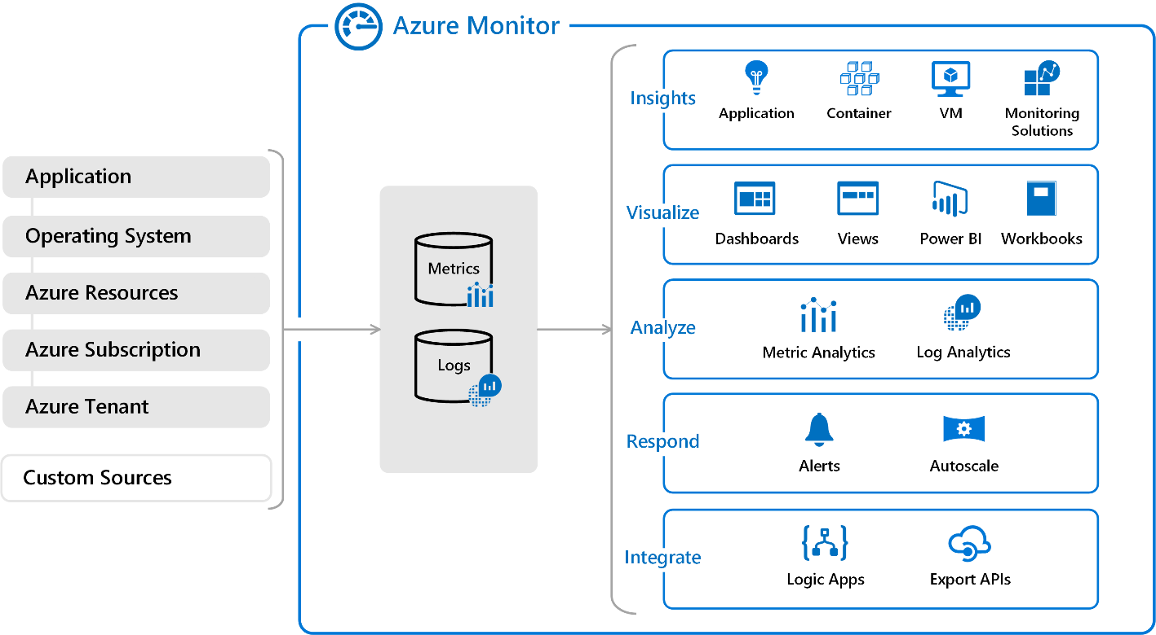

Figure 7: Azure Monitoring Tools

All of the servers will be backed up using the standard enterprise tool.

* 1. Maintenance Plan

All of the servers will be monitored by the standard enterprise tool, Operations Manager, for up/down status, disk, RAM and CPU utilization. All of the servers will be backed up using the standard enterprise tool, Data Protector. CEPRES Server Operations team will manage the servers. Server operating systems will be patched according to CEPRES capability standards.

1. Final Design

If the final design doesn’t match the proposed designed described in this document, this document will be updated accordingly to reflect the final design. The same applies to the “during” implementation phase.

# Appendix A - Terminology and Acronyms

Table 3: Abbreviations

| Abbreviation | Description |
| --- | --- |
|  |  |
|  |  |
|  |  |